**Install Java:**

Step 1: Verify that it is already installed or not

Check whether Java is already installed on the system or not. In my case, it is not installed therefore I need to install JDK 1.8 on my computer.

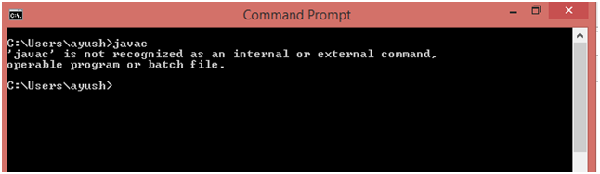  
Step 2: Download JDK

Click the below link to download jdk 1.8 for you windows 64 bit system.

[**Download JDK For Windows**](https://download.oracle.com/otn-pub/java/jdk/8u161-b12/2f38c3b165be4555a1fa6e98c45e0808/jdk-8u161-windows-x64.exe)

<https://www.java.com/download/ie_manual.jsp>

There are available releases for Linux and mac operating systems. You can visit the official link for JDK distributions i.e.

Click on the download option, it will download , then open the downloaded exe,click and run

4.ny Slashes PS5 Sales Projections Due to Global Chip Shortage

[**JDK Downloads**](http://www.oracle.com/technetwork/java/javase/downloads/jdk8-downloads-2133151.html)

Step 3: Install JDK

Open the executable file which you have just downloaded and follow the steps.  
Click **Next** to continue

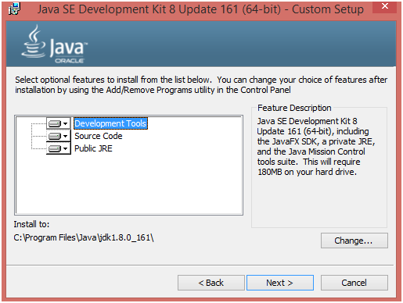  
Just Choose Development Tools and click Next.

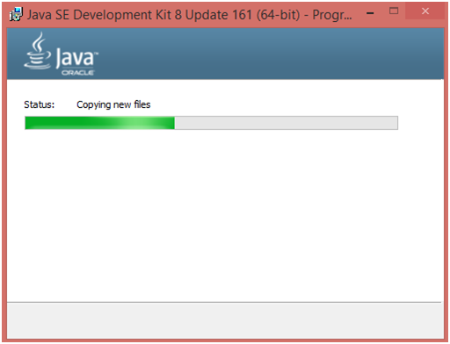

Set up is being ready.

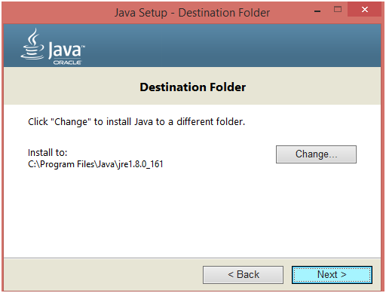

Choose the Destination folder in which you want to install JDK. Click Next to continue with the installation.

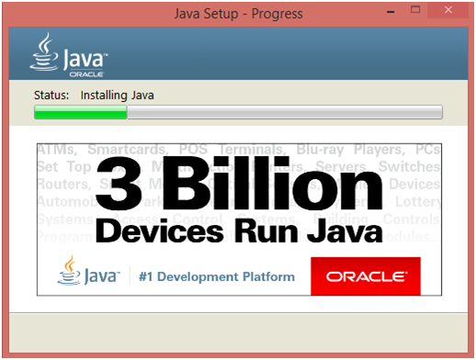

Set up is installing Java to the computer.

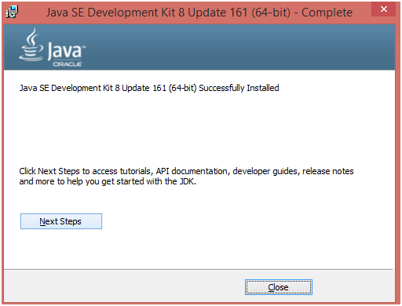

We have successfully installed Java SE development kit 8. Close the installation set up.

Step 4 : Set the Permanent Path

To execute Java applications from command line, we need to set Java Path. To set the path, follow the following steps.

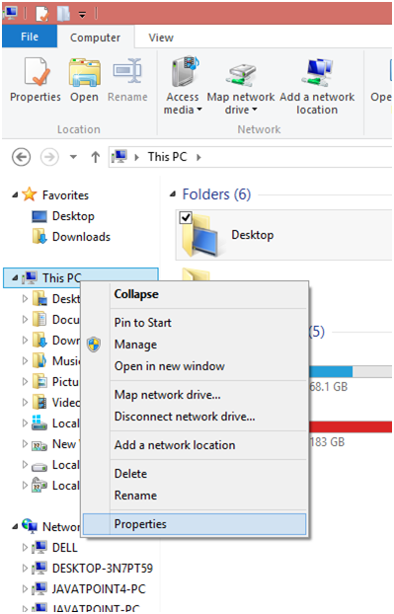

Right click on "this PC". It can be named as "My Computer" in some systems. Choose "properties" from the options.

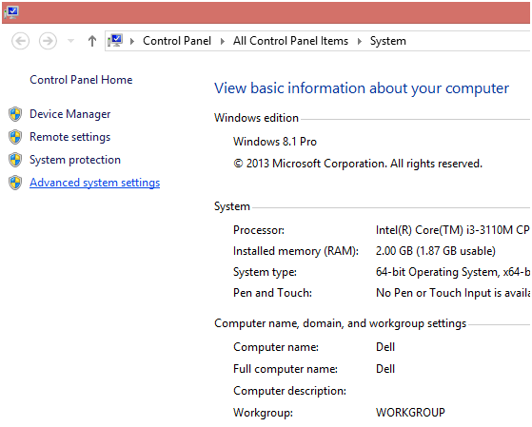

The screen look alike the above image will open. Click on "Advanced system settings" to continue.

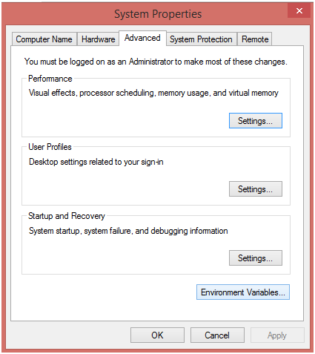

Above window will open. Click on "Environment Variables" to continue.

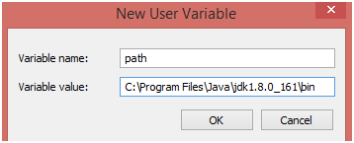

Enter "path" in variable name and enter the path to the bin folder inside your JDK in the variable value. Click OK.

Now Java Path has been set up. Open the Command prompt and type **"javac"** In case you have already open up the command prompt, I suggest you to close the existing window and reopen it again.

We will get javac executed as shown in the image below.

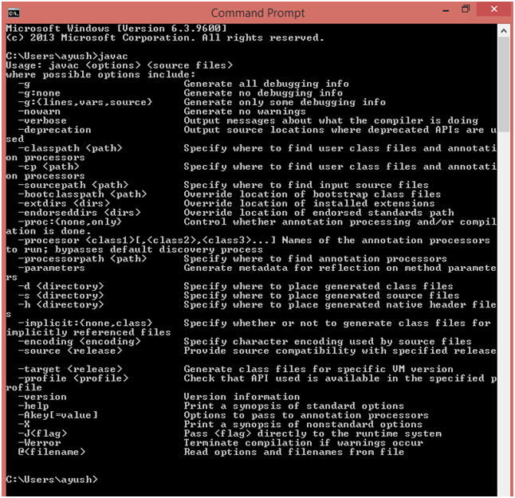

The Java has been installed on our system. Now, we need to configure IDEs like NetBeans or Eclipse in order to execute JavaFX applications.